Positive Interdependence and Cooperative Learning in Game Design:
13 Ways to Create a Positive Play Experience
It’s not uncommon to play a cooperative or competitive-cooperative game, such as League of Legends, and be bullied or yelled at. Online game communities are often referred to as uninviting or toxic. While much has been said regarding the anonymity of the internet and the terrible personalities of the people who post on web-based message boards, not as much has been said about how game designers can improve the quality of life for many of the players in these communities. Are there ways game designers can create games that don’t encourage poor, anti-social behavior and encourage players to foster a community outside of the game which creates an inviting place for people to hold discussions and accept others’ input? In other words, how do game creators design games in a way that doesn’t promote these toxic environments? By examining the principles of cooperative learning and, more specifically the concept of positive interdependence game designers can create something that not only allows for healthier team play, but also plants the seeds for a healthier game community.
The first step to uncovering why cooperative learning holds the key to a better cooperative experience in games is to recognize that games draw much of their fun from the process of learning. In Raph Koster’s seminal work A Theory of Fun for Game Design, he describes games as “…Teachers. Fun is just another word for learning (Koster 46).” This can easily be described in terms of a game such as League of Legends. When first entering a game, a player would assess her current knowledge of character interactions and strategies with her teammates and their characters. This knowledge would be followed during the first few skirmishes of the game. After a few skirmishes, the player might reevaluate her knowledge to determine efficacy. It the desired outcome has not been reached, her base knowledge will be changed and updated with new information gained from combat. This process will repeat on a micro level within games as well as on a macro level between matches and over the course of a player’s game career. Once a player gains enough knowledge to determine how to dismantle a foe easily, she will desire more difficult opponents to continue the learning process. This process closely mirrors the concept of flow first introduced by Mihaly Csikszentmihalyi and used to great degree in current game studies. From this perspective, one can see how the process of learning is incredibly important to player engagement in gaming.
Cooperative learning has been one of the most successfully implemented instructional practices in the past 60 years (Educational Researcher 365). To better understand the concept of cooperative learning it helps to compare the concepts of social interdependence and social dominance. Social interdependence theory is a core concept of cooperative learning and focuses on two types of interdependence theory: positive and negative (Relationships Among… 977). With positive interdependence, members of a group share common goals, members perceive that working together is individually and collectively beneficial, and success depends on the participation of all members. This creates an interaction pattern among group members of promotive interaction, and encourages the psychological process of substitutability (“…the degree to which actions of one person substitute for the actions of another person…”), inducibility (“…the openness to being influenced by and to influencing others…”), and positive cathexis (“…the investment of positive psychological energy in objects outside of oneself, such as friends, family, and work…”) (Educational Researcher 366). In the opposite way, negative interdependence encourages nonsubstitutability, negative cathexis, and a resistance to influence (Educational Researcher 366).
Immediately these ideas seem applicable to games and their design. Imagine members of a game community that encourage each other and are able to influence each other in positive ways, where members are investing positive energy in other people in the community. However, the question remains: does creating positive interdependence in a team environment expand past the boundaries of the magic circle and extend into the community itself. In a study on bullying performed by Jiyoung Choi, David W. Johnson, and Roger Johnson published in the Journal of Applied Social Psychology, it was found that positive interdependence does extend past these boundaries. This study was done to compare the concepts of social interdependence theory, described above, and social dominance theory, taking into consideration cooperative, competitive, and individualistic predispositions of the students. Social dominance is “…viewed as reflecting an individual’s desire for personal dominance over others…” (Relationships Among… 979). The study found that cooperative experiences were positively correlated to prosocial behavior while they were negatively correlated to harm-intended aggression (i.e. bullying). This is a good start for discouraging bullying within a game community. Positive predispositions towards competition were also found to be independent from participating in cooperative experiences, meaning even if an individual prefers competitive experiences, she is still open to cooperative experiences. In fact, it was discovered that cooperative experiences lead to cooperative dispositions, showing that predispositions can be learned. This also implies that the competitive and cooperative aspects of a game won’t cancel each other out. In perhaps the most important finding of the study for game communities, it was found that positive interdependence among goals results in promotive interaction and prosocial behavior. This shows the link between positive interdependence in a group setting and the community behavior at large. It was also shown that there was a negative link between harm-intended aggression and cooperativeness, showing that bullying is actually reduced by increasing cooperation. The summation of these findings proves that creating strong positive interdependence in a cooperative environment encourages better behavior and discourages bullying and anti-social behavior.
Positive interdependence is one of the five essential elements of cooperative learning, so it is necessary to critically look at cooperative learning in general (Educational Researcher). This is especially valid since cooperative learning has been shown to result in higher achievement, positive relationships and social supports, better psychological health and self-esteem, and reciprocal relationships, meaning that the harder people work together the more they tend to get along, which in turn makes them work harder together and continues the cycle (State of Cooperative… 19-22). Gaming communities would be markedly better if playing a game resulted in these outcomes. Imagine if playing a game of Dota 2 increased self-esteem and created a desire to face even harder opponents, every time. The results of cooperative learning are that impressive, and are summed up below.
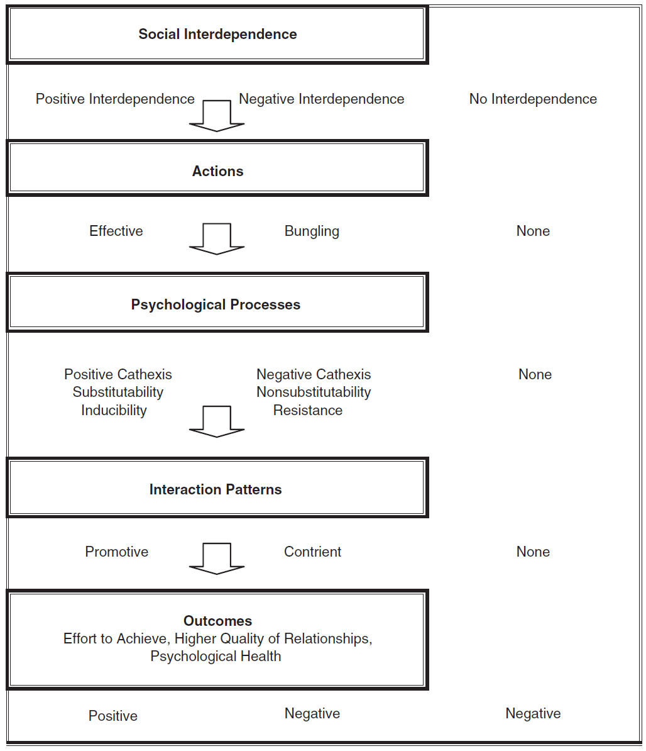
Figure 1. From "An Educational Psychology Success Story: Social Interdependence Theory and Cooperative Learning"
Now the case has been built for encouraging positive interdependence and cooperation in order to improve the communities and experiences of cooperative and competitive-cooperative games, but it remains to be determined how a designer can create a strong positive interdependence in a game. In An Educational Psychology Success Story: Social Interdependence and Cooperative Learning, three different methods of achieving positive interdependence were outlined. The first is outcome interdependence, which consists of structuring goals and rewards for a group and not an individual. Video games tend to do this fairly well already. However, most team-based competitive games do still reward the individuals who perform better in a game over other individuals on a team, even in losing situations. This tends to increase negative interdependence. The next way to achieve positive interdependence is through means interdependence. This consists of role, resource, and task interdependence. These methods overlap, and are not independent of each other. Games are reasonably good at this, but they tend to separate these items to such an extent that sharing is no longer necessary, which is a requirement of means interdependence. Group members must share the means to the goal. The final method is boundary interdependence, which is a sectioning off of teams with each other, either symbolically or physically. Games actually do this quite well, as one can look at any well-designed team death-match in a first person shooter, such as Halo or Call of Duty, and easily determine who is a member of which team, whether that be Red v. Blue or S.A.S. v. Spetsnaz.
While the focus so far has been on positive interdependence, there are four other essential elements to cooperative learning, as mentioned previously, and an aspect of positive interdependence not yet covered. As for positive interdependence, it is not enough to just create it; one must also minimize negative interdependence in a group. This means minimizing oppositional goals as well as creating shared goals and outcomes. The groups should also not have a different distribution of benefits, such as a star performer receiving more benefits than other people in the group. Lastly, a one-way dependence on resources will create a negative interdependence. Resources must be split and shared equally between all members of a group (Peace in the Classroom 235).
The next essential element of cooperative learning is individual accountability. Positive interdependence creates responsibility forces that add the concept of members pulling their weight. Individual accountability exists when the performance of each group member is assessed and the results are given back to the individual and the entire group (An Educational Psychology… 368). Games are very good at serving up metrics of kills, deaths, and assists or any number of point based systems. However, the pitfall to watch out for here is the concept of social loafing. Social loafing occurs when group members reduce their contributions because it’s difficult to identify individual contributions, and this tends to occur more often as the size of the group gets larger (An Educational Psychology… 368). This was a problem in the early days of World of Warcraft. In the 40-person team battles called raids, often times many members would leave their keyboard when easy enemies were being faced, or when bosses were easy enough they didn’t need to be present. However, once a certain number of people did this, the odds were insurmountable once again. World of Warcraft has since taken down the number of people required for a large raid to 25 and had great success limiting social loafing.
Promotive interaction is the third essential element of cooperative learning. It “…occurs as individuals encourage and facilitate each other’s efforts to accomplish the group’s goals (An Educational Psychology… 368).” There are many ways in which promotive interaction is characterized, but the following are the most relevant to play: exchanging needed resources, acting in trusting and trustworthy ways, and having low anxiety and stress. Positive interdependence creates promotive interaction, and with that things such as low anxiety. If game designers create games with these concepts, anxiety should be low and people should exchange resources readily. If one considers games such as many of the social web-based games, there is no exchange of resources, and it becomes stressful to convince friends and family to continue giving the player what he needs to keep playing. This is a very negative interdependence given the one-way dependence on resources, and it promotes very oppositional interaction, such as not giving a friend a free resource for the sole purpose of creating a better farm, city, etc. Figure 2 below visually explains the relationships formed by creating a positive interdependence, starting from the outside in.
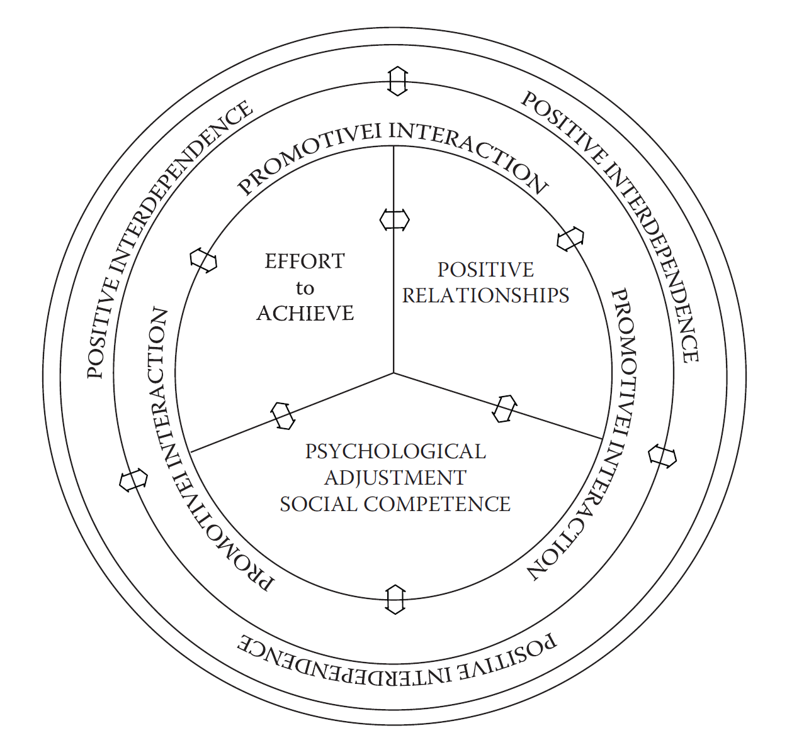
Figure 2. From "Teaching Students to be peacemakers: Results of twelve years of research"
An appropriate use of social skills during an online death-match may be difficult, but it is the next essential element of cooperative learning. However, while game designers may not be able to ensure every player will use their social skills appropriately, they can help them communicate accurately and unambiguously, which is one of the main facets of using social skills appropriately. According to An Educational Psychology Success Story: Social Interdependence Theory and Cooperative Learning, “Unskilled group members cannot cooperate effectively.” While this may be true, game designers can go to great lengths to ensure that the game will allow them to do this. For instance, imagine in Heroes of Newerth, another of the Dota-style Multiplayer Online Battle Arenas (or MOBAs), if before the player unleashed a stun move on an enemy she could visually show other players in the vicinity she was using this stun move, simply by queuing the ability and putting her mouse cursor over that enemy. In this case, the game may use a User Interface element to denote a stun, and no verbal communication would be needed. In this way and many others, game designers could allow for easier and less ambiguous communication among all players, regardless of social skill levels.
The final element is that of group processing. Group processing consists of reflecting on which actions were helpful or unhelpful and making decisions about continuing to perform these actions or changing them (An Educational Psychology… 369). While this may not be something that game designers could put in a game easily, they could encourage this type of interaction by simply keeping teams together longer if they were randomly paired up, or increasing the likelihood that a person will be paired with another player again if they played well together during previous matches. By encouraging teams to stay together, it increases the likelihood they’ll cooperate, and “…cooperation promotes considerably greater effort to achieve than do competitive or individualistic efforts (Teaching Students… 227).”
The last piece of this puzzle that needs to be placed is the question regarding competition and its benefits. Competition has been shown to be constructive, and it should be encouraged when it is appropriately structure (An Educational… 370). As games tend to be very competitive, how do designers limit the negatives of competition while still keeping the constructive elements of competition in tact? First and foremost, winning needs to be relatively unimportant. When winning is too important, people tend to get stressed, and this interferes with performance. Games are generally not very good at this, as they tend to reward the winner far more than the loser. Winning is everything more often than not. Secondly, all participants must have a reasonable chance to win. Games are actually very good at this, and have very sophisticated matchmaking algorithms to ensure equal chance. Starcraft II’s matchmaker attempts to place all players at a fifty-percent win rate. Finally, rules must be clear and specific. Games are also very good at this, if the game is well designed (An Educational… 370).
Looking at the concepts of positive interdependence and cooperative learning have shown a great deal about how games can encourage prosocial behavior in their communities, and how poorly many games handle some of the principles of these concepts. Games need to focus on a more of these concepts that may seem foreign to genres such as first person shooters or MOBAs. Some games do things better than others though. Guild Wars 2 is a good example of a game that communicates clearly, has great resource sharing, and overall creates a great amount of positive interdependence. However, even Guild Wars 2 doesn’t have roles that are well defined within a group, but the community around the game is exceptionally welcoming and civil. Games might not need all of the concepts discussed, but the more of them a game incorporates, the better the experience and psychological health of everyone playing, and possibly encouraging people to play the game longer to tackle more difficult tasks. Below is a list of 13 ways to create a positive play experience:
- Rewards and goals are for the entire group, not individuals.
- Roles, resources, and tasks should be well-defined but overlap. Sharing is a must between these.
- Define boundaries. Red v. Blue is good for team morale.
- Minimize oppositional goals. Players should mostly share the same goals, individual and group.
- The best players on a team shouldn’t be rewarded more than the worst players on a team.
- Resource sharing should not be a one-way street, this creates a power struggle.
- Everyone needs to know how well they did, in front of the team. No loafing.
- Keep team sizes small. Five is a good number.
- Allow the game to communicate for the player. Make sure communication is unambiguous.
- Keep teams together. Allow people to process wins and losses as a group.
- Winning shouldn’t be everything.
- Everyone should have a reasonable chance to win though.
- Victory conditions and strategies should be clear and understandable.

Remember, creating a positive interdependence among team members improves psychological health and self-esteem, makes people work harder and longer, and encourages people to help each other out. There are no silver-bullet mechanics, but focusing on the above list will get the game designer a long way towards creating a game with a great community who respect one another.

Works Cited
Koster, Raph. A Theory of Fun for Game Design. Scottsdale: Paraglyph Press, 2005. Print.
Johnson, David W., Jiyoung Choi, Roger Johnson. “Relationships Among Cooperative Learning Experiences, Social Interdependence, Children’s Aggression, Victimization, and Prosocial Behaviors.” Journal of Applied Social Psychology 41.4 (2011): 976-1003. Print.
Johnson, David W., Roger T. Johnson. “An Educational Psychology Success Story: Social Interdependence Theory and Cooperative Learning.” Educational Researcher 38.5 (2009): 365-379: Print.
Johnson, David W., Roger T. Johnson, Karl Smith. “The State of Cooperative Learning in Postsecondary and Professional Settings.” Educational Psychology Review 19 (2007): 15-29. Print.
Johnson, Roger T., David W. Johnson. "Teaching students to be peacemakers: Results of twelve years of research". Handbook on Peace Education. Ed. Salomon, Gavriel. Psychology Press, 2000. 226–227. Print.

